Sorting

Tutorial -6

Q.1. Given the following list of numbers:

[21, 1, 26, 45, 29, 28, 2, 9, 16, 49, 39, 27, 43, 34, 46,40].

• What will be the array after 3 recursive calls to merge sort?

• How many recursive calls are needed to sort the array?

Keys having collison: 1989,4199,6171

Q2. Write a program to implement counting sort having functions:

o Function to sort an array of integers

o Function to sort an array of characters

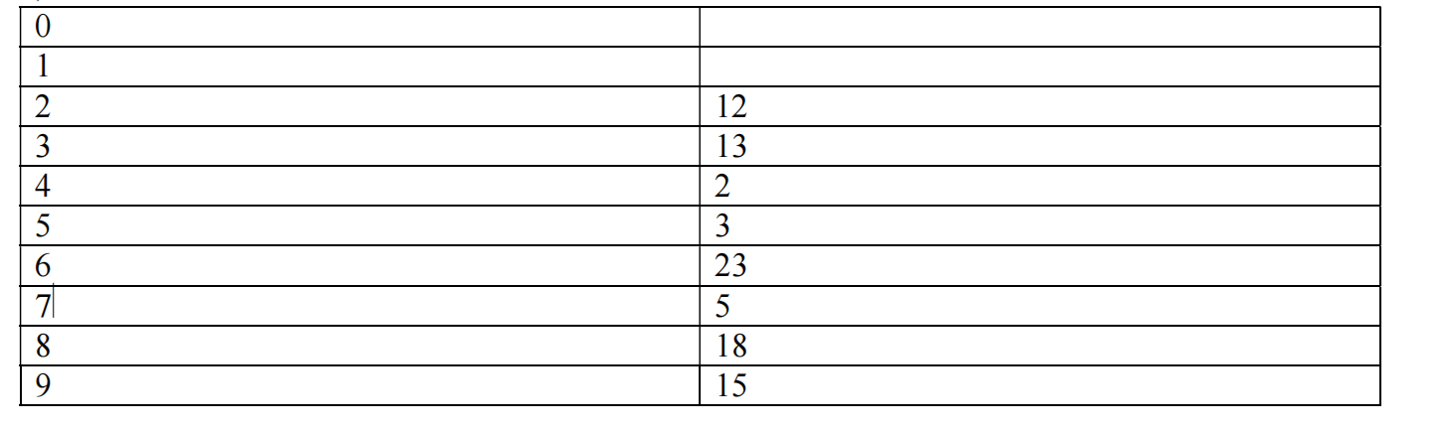

Q.3. Using Radix sort algorithm write functions to sort the following array

o Function1: Arr = [10,21,17,34,44,11,654,123]

o Function2: Arr = [abc, def, fgh, hjk, ihl, wqb, asz, xtn]

Assumption for function 2 is: strings in array will have a fixed length of 3

(C) 46, 34, 42, 23, 52, 33

Q.4 Given an array of integers (both odd and even), sort them in such a way that the first part of the array contains odd numbers sorted in descending order, rest portion contains even numbers

sorted in ascending order.

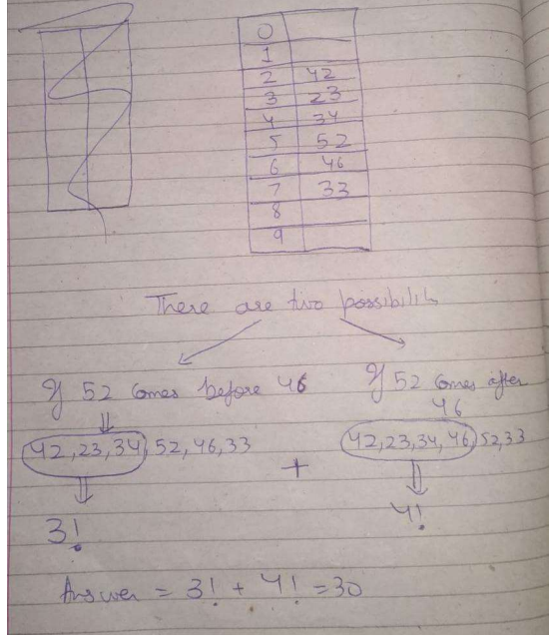

Q.5. In one day match of cricket, write a program to get input of x number of balls and score achieved at the respective ball. Keep track of total singles, doubles, fours and sixers and print the way (via singles, doubles , fours or sixers) by which maximum scores are achieved .

